A REPORT ON

**“Reliance Industries Limited” is planning to enter the Airline**

**Industry.**

By

### Group No: 12

**Under Supervision of** DR.SUNNY KUMAR SINGH

**Course Code**: ECON F411

**Course Title**: PROJECT APPRAISAL



**BIRLA INSTITUTE OF TECHNOLOGY AND SCIENCE, PILANI HYDERABAD CAMPUS**

**(12 November 2022)**

# Group Details

Group Number: 12

|  |  |  |
| --- | --- | --- |
| **S. No.** | **Name** | **ID No.** |
| 1 | MANDA SRI DATTA  SATYANARAYANA PHANI SRINIVAS | 2020A4PS0551H |
| 2 | VAISHNAVI  POTLADURTHY | 2020A4PS1967H |
| 3 | PARIMI NAXITH ABHIRAM | 2020A4PS0850H |
| 4 | SOWRISH SAI SURAPANENI | 2020A4PS1525H |
| 5 | SUJITH GARAPATI | 2020A4PS1922H |
| 6 | CHARAN ATLURI | 2020A4PS0782H |

# CONTENTS

|  |  |
| --- | --- |
| Acknowledgement | 2 |
| Introduction | 4 |
| Market analysis | 5 |
| Choosing Appropriate Technology | 7 |
| Inputs, utilities | 9 |
| Capacity | 10 |
| Location and Site | 11 |
| Machine | 11 |
| Conclusion | 12 |

## ACKNOWLEDGEMENT

An activity can be named as an achievement just when its motivation is satisfied. Its achievement includes consistent undaunted exertion, inspiration, and lasting help from its mentors. We would like to take this opportunity to thank our professor Prof. Sunny Kumar Singh, for invaluable guidance throughout the course.

## INTRODUCTION:

This assignment analyzes all the factors to be considered while starting a new project for our project. We will carefully analyze factors that are to be looked after while entering the Airline industry. The project's title is

“ Reliance Industries Limited,” which is planning to enter into the Airline Industry.”

Now let us look at the factors that we are going to consider and analyze for the Airline industry

* Choosing Appropriate Technology
* Inputs, utilities
* Product Mix
* Capacity
* Location and Site
* Machine
* Layout if possible

We will be discussing these factors profoundly and try to analyze the industry and try to enter into it efficiently, and we try to be successful in that industry

We will also try to discuss the problems faced in each aspect so that we may get any idea how to deal with them not only in the appraisal of this project but also in any possible future project

First we will also do a fundamental market analysis of AIrline industry to first know about the competition we are going to face and also try to get familiar with the supply chain of the industry and its related aspects, Marketing, and Management, etc.

### MARKET ANALYSIS:

The air transport market analysis could help with route and network planning decisions and increase airline revenue and profitability by outlining a market's drivers, characteristics, and trends.

From 2022 to 2027, the worldwide airline industry market is anticipated to expand at a CAGR of 25.5%. Due to rising disposable income, a rapidly growing middle class, and rising travel demand, the global aviation industry is expected to develop during the coming years.

Additionally, the cost of jet fuel is anticipated to be relatively steady during the forecast, enabling airlines to impose surcharges and generate extra money from transporting passengers and cargo.

International trade in manufactured goods, notably in the components sector, which makes up a sizeable portion of current cross-border trade, depends on air transportation. This year, international trade transported by air will be worth $7.5 trillion, an increase of 15% from 2019, and it will increase by an additional 7.2 percent in 2022. Increased tourist spending on air travel—which reached $354 billion in 2021—is another factor driving industry expansion.

High government support in the form of capital infusions, loans, deferred tax payments, and reduced tax obligations for airlines are among the factors driving market expansion throughout the forecast period. It is predicted that employment opportunities in the airline industry will increase by 10.8% in 2022.

The market for the airline sector is segmented into passenger and freight aircraft based on how commercial airlines operate. From 2022 to 2027, the fastest-growing segment is anticipated to be the freight aircraft segment. This market is expected to grow, resulting in integrated airfreight services becoming more and more well-liked and quick shipment delivery compared to other alternative logistics solutions. In addition, it is anticipated that the use of cool-chain technology, robotics, automated systems, and artificial intelligence over the forecast period.

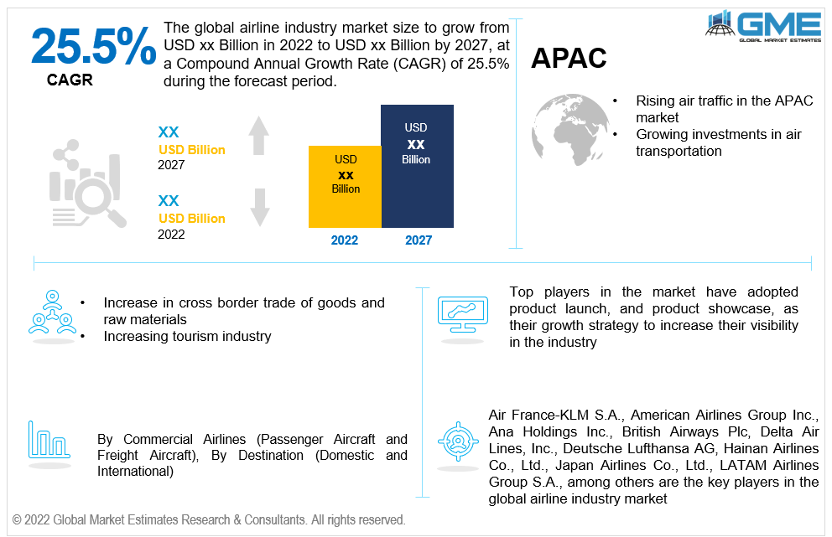

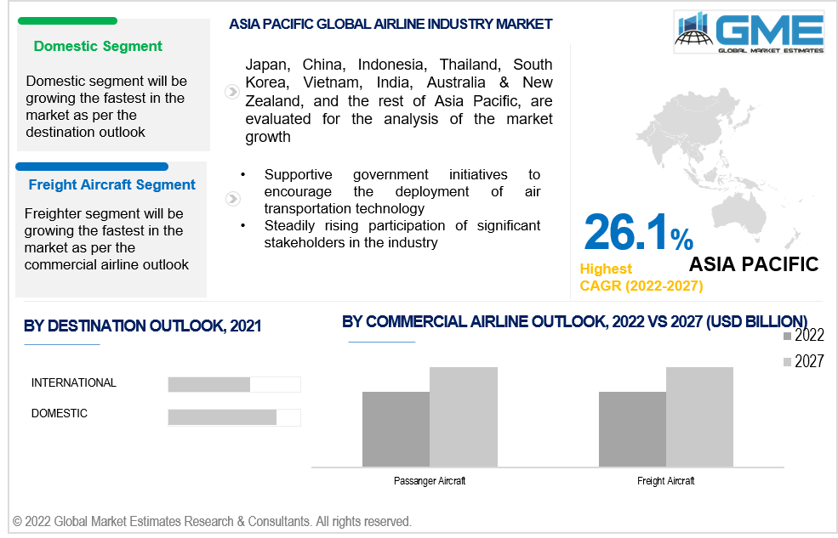

### Choosing Appropriate Technology

In this part, we are going to deal with the technologies related to the complete airline business-like, like the aircraft models that we are going to use for fuel and ticket booking, Payment technologies. First, let us deal with the Flight that is to be used, their classification based on freight or passenger, and the best viable option for them individually

Let us discuss first the passenger class aircraft, which are also divided into 2 types domestic and international for the domestic the best choice for aircraft are Airbus A320.

Which will cost around $101 million their maintenance costs are also decent because they are frequently used, and many airspace colleges study them thus, technical teams are pretty readily available and substitute for this will be the Boeing 737- 900ER and which costs around $112.6 million and maintenance costs aren't also that high. These are the **cash cows** of the company

Now for international services we need Jumbo jets which have high maintenance and need to be very careful while choosing so that it must not any inconvenience for passengers who are going to have a very long journey and for this purpose the best available options are Boeing 747 and Airbus A380 so this very large birds and they can carry a very large chunk of people now they have many benefits that will help in long journeys next thing is that these flights have different categories tickets so that the customization of the plane is needed which needs a lot of places and these birds provide it they are high priced and need high maintenance but this is the **Star product** of companies

Now let us discuss About ticketing so The airlines Shell out massive

amount of money in advance to run the airline route so they want to make sure that the get paid for each and every ticket on the plane so it will be a complex data science involved process to optimize the proper result When a traveller makes a flight search on an airline's website, the request is sent directly to the CRS of the company, bypassing any intermediaries. The CRS returns a list of alternatives that fit the necessary dates. Uncomplicated and straightforward in nature! However, more often than not, the options will be restricted to flights operated by a specific airline and its affiliates.

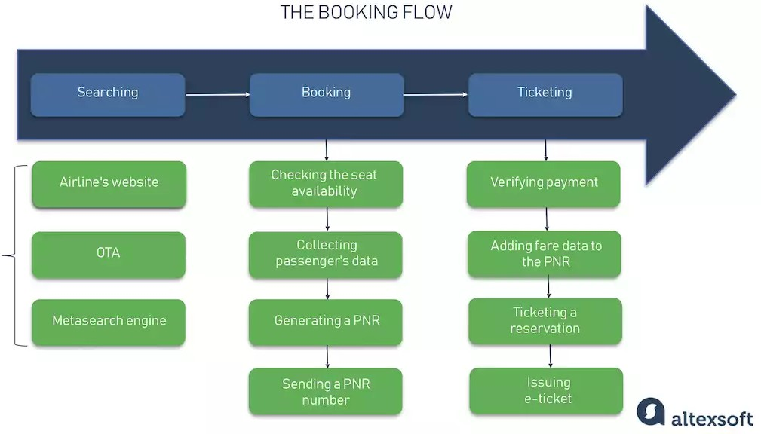

### Inputs, utilities

Golightly (1967) discovered in his research that the fundamental difficulties faced by the aviation industry during its expansion included relying heavily on short-term borrowing and a recurrent demand for huge sums of money. A rising need on insurance resulted from rapid equipment and technology advancements

facilities and the introduction of jets, which resulted in additional seats to sell. These expenses have a new, contemporary form today.

In their investigation of Jet Blue Airlines, Daramaju et al. (2007) came to the conclusion that security precautions and safety are crucial factors for airlines (as cited in Dess et al, 2008). Terrorist attacks have significantly harmed airlines, leading more people to choose alternate forms of transportation. According to Yang (2007), the majority of airlines were at their most prosperous before the 9/11 terrorist attacks. The attacks caused a serious setback, and now more people choose other forms of transportation than flying.

Costs have increased as a result of investing in facilities and machinery for tracking and bag-screening. Fuel cost increases lead to high operating expenses and high labour costs, which have a negative impact on profits. According to Regani's 2008 report "JetBlue Airways; Growing Pains?," global fuel prices abruptly increased in 2004. Fuel now accounts for 20% of operating costs in the aircraft industry, up from 10% to 14% previously. This increased to 30% in 2005 and to 35% in 2006. (as cited in Barney & Hesterly, 2010). Up until now, the increase has been constant. Most airlines use fuel cost hedging, whereby they buy fuel in advance at a set price for future delivery, protecting themselves against the shock of projected price increases (Keynes, 2009). The current political unrest in oil-producing nations like Libya has greatly contributed to the increase in fuel prices. Revenue and even product prices reflect this expense. Despite all the difficulties, the unstable and quickly changing environment makes the situation more difficult.

The primary product of the airline sector is transportation. Since a service is intangible, a corporation can set itself apart from its rivals by offering a number of obvious signs, such as:

* Food and Drink
* Uniforms for the music crew at Air India are blue saris with prints.
* Mascots and logos for Air India include a centaur and a maharaja. Jet Airways' tickets are blue in colour and design.
* Cushions and seats
* Fax, computers, audio/video equipment for business or pleasure, etc. Baggage pickup
* Flight reservations

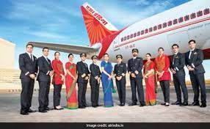

### PRODUCT MIX

The most crucial marketing task is choosing the proper product. No amount of price reduction or clever marketing will persuade customers to purchase a product if the market doesn't demand it. The airline product is particularly complicated since it includes both a service that incorporates the temporary user of an aircraft seat and some physical products, such complimentary flying bags or a complimentary bottle of duty-free liquor to promote booking

Two categories of services are included in the airline product:

1. services on the ground,
2. Onboard services.

A convenient airport with vehicle parking options, duty-free shopping, quick and efficient baggage checks, effective assistance at the reservation counter, transportation to the airport, etc. are some of the on-the-ground services offered

**CUSTOMERS**: Customers are people with specific needs, wants, and preferences. The business gives customers promises. Customers in the airline sector are those who feel the urge To move from one location to another. The clients are further divided into Individual and Institutional categories.

Institutional clients are businesses that frequently need to travel their leaders and personnel. As a result, they hold reservations or block bookings with the airlines.

**COMPANY**:The business is the offeror and the dreamer. The business comes up with a service concept that will meet client expectations. The company was founded with the primary goal of offering the particular transport service. As a result, the airline business was created, with firms like Indian Airlines, Jet Airways, Sahara Airlines, etc.

**PROVIDERS** : The individuals (employees) who engage with the consumer are finally listed here. They are responsible for completing the last transaction. The customer's involvement with company personnel serves as their point of contact with the business. By establishing up infrastructure to deliver the promises, such as ticket and inquiry counters, the corporation gives its staff everything they need to fulfill their obligations. To maximize the transaction's quality, the organization tries to provide its providers with the necessary infrastructure and training. For instance, Sahara Airlines conducts annual staff performance reviews and training programs.

The following are the strategic points where the provider and the client interact:

Requesting information about services, flight schedules, routes, etc., purchasing tickets from airlines or travel companies, Signing in, Throughout boarding,The personnel on board,As we were boarding.All three sides of a triangle must come together to form the whole. Each of the three marketing initiatives for services represented by the triangle's sides must be in place for the triangle's or the overall marketing effort to function as effectively as possible.

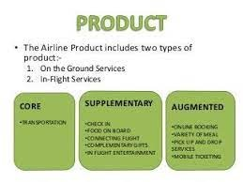

### CAPACITY

We can classify the capacity in many ways: Theoretical capacity, Practical capacity, standard capacity, master- budget capacity, and capacity.

* Theoretical capacity is a concept bbased on denominator level producing at full efficiency all the time.
* Practical capacity a concept that reduces theoretical capacity by unavoidable operating interruptions such as maintenance time, hutdowns for holidays, and so on.
* Nomal capacity is based on the level of the capacity utilization that satisfies average customers demand over a time period including the seasonal, trend analysis.
* Master- budget capacity is on the expected level of capacity utilization for upcoming budget period.
* Actual capacity is atual usage of current production capacity.

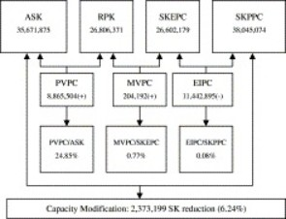

***Note*:**

* ASK: Available Seat Kilometers
* RPK : Revenue Passenger Kilometers
* SKEPC: Seat Kilometers of Expected Sale Passenger Capacity.
* SKPPC: Seat kilometer of Practical passenger
* PVPC: production Variance of Passenger Capacity
* MVPC: Marketing Variance of Passenger Capacity
* EIPC: Expected Idle of Passenger Capacity.

The above figure gives a brief about production capacity, marketing variance and expected idle passenger capacity. Firstly, having a positive productive capacity indicates that actual supply exceeds sales of flight capacity. Positive marketing variance indicates actual sales exceed expected sales of flights capacity.

Negative expected idle capacity implies that expected sales are below the practical capacity.

### Location and Site

Another significant configuration i.e. required is location and site, which is important for the spare parts inventory allocation, avoiding shortage or waste of airlines spare parts, improving utilization rate of airlines spare parts, ensuring the reliability of dispatch, and reducing operating costs. The METRIC theory is developed based on establishing a two-level maintenance support system and optimization model. The replacement of spare parts at each maintenance stage is very important, so collectively selecting the location and site will play a vital role.

### Machine:

While entering into the Airline Industry, the other important element is the application, and manufacturing of machinery with the latest technology equipped. AI is all around streamlining automated analytics, machinery maintenance, customer service, and many more. Delta, one of the world’s largest global airlines, leverages AI to optimize operations and costs, as well as innovate customer service at every stage of a trip. Such an example set up the standard to have an efficient machine. Recently added digital twin technology is something to create a full-scale simulation environment that processes tons of data points, which predicts possible outcomes, equips decision-makers to handle disruptions, and ensures safety. And many such improvements in the latest technology imply changes in the machinery.

### Layout:

In order to encompass the aspects of pilot condition and flight condition, a taxonomy of operating circumstances were established. Following that, it explores how different human operator types would divide up their tasks, as well as potential ground operator unit organizational structures and the kinds of services their operators would be able to offer the captain. Then, an options space with dimensions spanning the quantity of air-ground operators and the degree of automation was looked at; it was discovered that the most cost-effective solution is not always found by reducing the overall number of operators. The specifications for sophisticated cockpit automation were then given. When taken as a whole, the aforementioned information clarifies the tasks and roles of different air and ground operator positions, as well as the equipment needed for them to work together and on their own.

### Conclusion

Textile to telecom giant Reliance industries is eyeing a major chunk now in airlines already owning the Boeing Business Jet, Falcon 900Ex jet and an Airbus 319.

After having a close observation on the key formulation on product strategy, annual reports and recent news on ‘Reliance having an eye in the grounded Jet Airways’. We can say that there is a very high chances of Reliance getting into the airline industry. Though not directly as a proper competitor in the industry but surely by taking up percentage stakes. i.e. Reports say that Reliance industries may join Etihad Airways which controls 24% stake in Jet airways.

### Reference:

[*https://www.globalmarketestimates.com/market-report/airline-industry-market-3733*](https://www.globalmarketestimates.com/market-report/airline-industry-market-3733)[*https://www.financialexpress.com/industry/reliance-eyes-stake-in-jet-airways-explores-bailing-out-air-india/1553995/*](https://www.financialexpress.com/industry/reliance-eyes-stake-in-jet-airways-explores-bailing-out-air-india/1553995/)[*https://www.ncbi.nlm.nih.gov/pmc/articles/PMC7147867/*](https://www.ncbi.nlm.nih.gov/pmc/articles/PMC7147867/)

[*https://www.hindawi.com/journals/cin/2021/4737700/*](https://www.hindawi.com/journals/cin/2021/4737700/)[*https://www.altexsoft.com/blog/engineering/ai-airlines/*](https://www.altexsoft.com/blog/engineering/ai-airlines/)

[*https://www.researchgate.net/figure/Representative-layout-of-airline-operations-center_fig3_300244822*](https://www.researchgate.net/figure/Representative-layout-of-airline-operations-center_fig3_300244822)